Kindergarten Math Report Card Expectations

Below is an overview of what students will be assessed at each grading period.
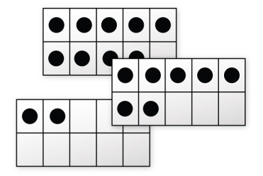
First Grading Period
By the end of the first grading period, students should
- Read, write, and represent the numbers 0-5.
- Compose (to create by putting the parts together) the numbers 2-5.
  - (i.e. 2 and 2 make 4; 3 and 1 make 4)
- Decompose (breaking numbers apart) the numbers 2-5.
  - (i.e. If you have 5 blocks, hide them and keep 2 hidden, show the 3 blocks- How many do I have hidden?)
- Name 2D shapes: circle, square, triangle, and rectangle.
- Identify attributes (characteristics used to describe an object) of: circle, square, triangle, and rectangle.
- Sort 2D shapes by attributes.
- Count sets of objects with one-to-one correspondence (students assign one number to each object as they count) up to 10. Students also know that the last number said tells the number of objects in the set.

Websites:
Ten Frames
http://illuminations.nctm.org/ActivityDetail.aspx?id=75

Shape Pictures
http://www.eduplace.com/kids/mw/swfs/robopacker_grade4.html

Number Track
http://www.crickweb.co.uk/ks2numeracy-properties-and-ordering.html#ntrack

Concentration-Matching the Number to the Quantity Shown
http://illuminations.nctm.org/ActivityDetail.aspx?ID=73
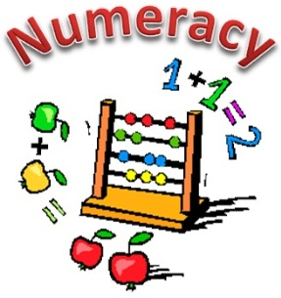
Second Grading Period
By the end of the second grading period, students should
- Read, write, and represent the numbers 0-10.
- Compose the numbers (putting numbers together) 2-10.
- Decompose (breaking numbers apart) the numbers 2-10.
- Name 3D shapes: sphere, cube, cylinder, and cone.
- Identify attributes of: sphere, cube, cylinder, and cone.
- Sort 3D shapes by attributes.
- Count sets of objects with one-to-one correspondence up to 15.
- Generate a number that is one more or one less than another number up to 10.
- Generate sets to compare objects with more, less, and the same number as a shown set.
- Count forward to 10 from any number.
- Count backward to 0 from any number less than 10.

Websites:

Counting with Curious George
http://pbskids.org/curiousgeorge/busyday/flowers/

Counting to 10
http://www.sheppardsoftware.com/mathgames/earlymath/BalloonCount10.htm

3D Shapes Concentration
http://www.math-play.com/3d-shapes-game/3d-shapes-game.html

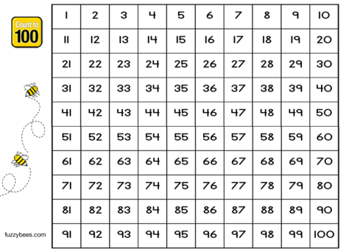
Third Grading Period
By the end of the third grading period, students should
- Read, write, and represent the numbers 0-15.
- Compose and decompose the numbers 2-10.
- Count sets of objects with one-to-one. correspondence up to 20.
- Generate a number that is one more or one less than another number up to 15.
- Count forward to 20 from any number.
- Count backward to 0 from any number less than 20.
- Generate sets to compare objects with more, less, and the same number as a shown set up to 15.
- Count by tens to 100 on the decade starting at any number (i.e. 20, 30,40 ..).
- Models addition and subtraction problem when given the problem orally.

Websites:

Number Twins
http://illuminations.nctm.org/ActivityDetail.aspx?ID=73

Bugabaloo Shoes
http://www.sheppardsoftware.com/mathgames/earlymath/bugabalooShoes.htm

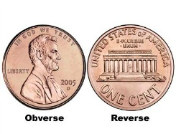
Fourth Grading Period
By the end of the fourth grading period, students should
- Read, write, and represent the numbers 0-20.
- Compose and decompose the numbers 2-10.
- Generate a number that is one more or one less than another number up to 20.
- Generate sets to compare objects with more, less, and the same number as a shown set up to 20.
- Count by ones to 100 starting at any number.
- Model addition and subtraction problem when given a number sentence.
- Identify the coins: penny, nickel, dime, and quarter.
- Identify the longest or shortest object in a group.
- Identify which object weighs more/less in a group.

Websites:
Coin Identification (Note: Kindergarteners are only identifying coins by name)
http://www.softschools.com/math/money/identify_coins/
http://www.abcya.com/learning_coins.htm

Number Twins
http://illuminations.nctm.org/ActivityDetail.aspx?ID=73

Bugabaloo Shoes
http://www.sheppardsoftware.com/mathgames/earlymath/bugabalooShoes.htm

Number Track
http://www.crickweb.co.uk/ks2numeracy-properties-and-ordering.html#ntrack

